Project Design Phase-II
Technology Stack (Architecture & Stack)

Date | 14 July 2026
Team ID | SWTID-2026-7950
Project Name | ONLINE COMPLAINT REGISTRATION
Maximum Marks | 4 Marks

Technical Architecture:
The Deliverable shall include the architectural diagram as below and the information as per the table1 & table 2
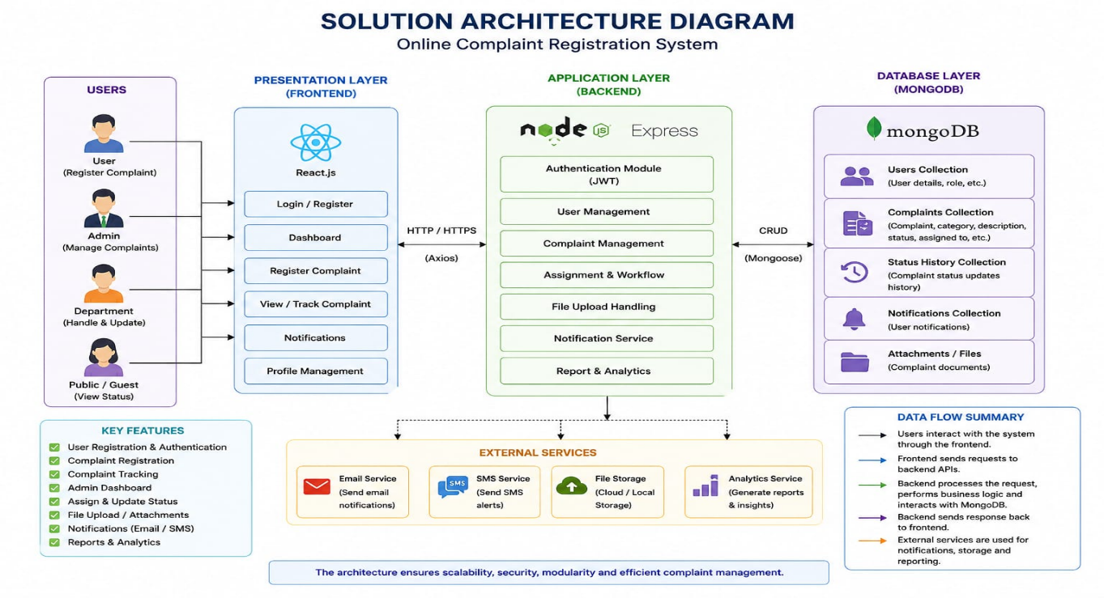
Example: Order processing during pandemics for offline mode

Table-1 : Components & Technologies:
S.No | Component | Description | Technology
1 | User Interface | Web-based interface for users and administrators to register, track, and manage complaints | HTML5, CSS3, JavaScript, React.js
2 | Backend Application | Handles authentication, complaint processing and REST APIs | Node.js, Express.js
3 | Authentication | Secure login and role-based access control | JWT, bcrypt
4 | Complaint Management | Register, assign, update and track complaints | Node.js, Express.js
5 | Database | Stores users, complaints and status details | MongoDB
6 | File Storage | Stores complaint attachments and documents | Local Storage / Cloud Storage
7 | Notification Service | Email/SMS notifications for complaint updates | Nodemailer, Twilio
8 | Reporting & Analytics | Generate reports and complaint statistics | Chart.js, React.js
9 | Infrastructure | Application deployment and hosting | Docker, Nginx, Linux / Cloud

Table-2: Application Characteristics:
S.No | Characteristics | Description | Technology
1 | Open-Source Frameworks | Frameworks used for application development | React.js, Node.js, Express.js
2 | Security Implementations | Authentication, password encryption, API protection | JWT, bcrypt, HTTPS, OWASP
3 | Scalable Architecture | Three-tier architecture with REST APIs | React, Node.js, MongoDB
4 | Availability | Reliable deployment with backup and monitoring | Docker, Nginx, Cloud Hosting
5 | Performance | Optimized database queries, caching and API responses | MongoDB Indexing, Compression

